Hive:

Bucket:

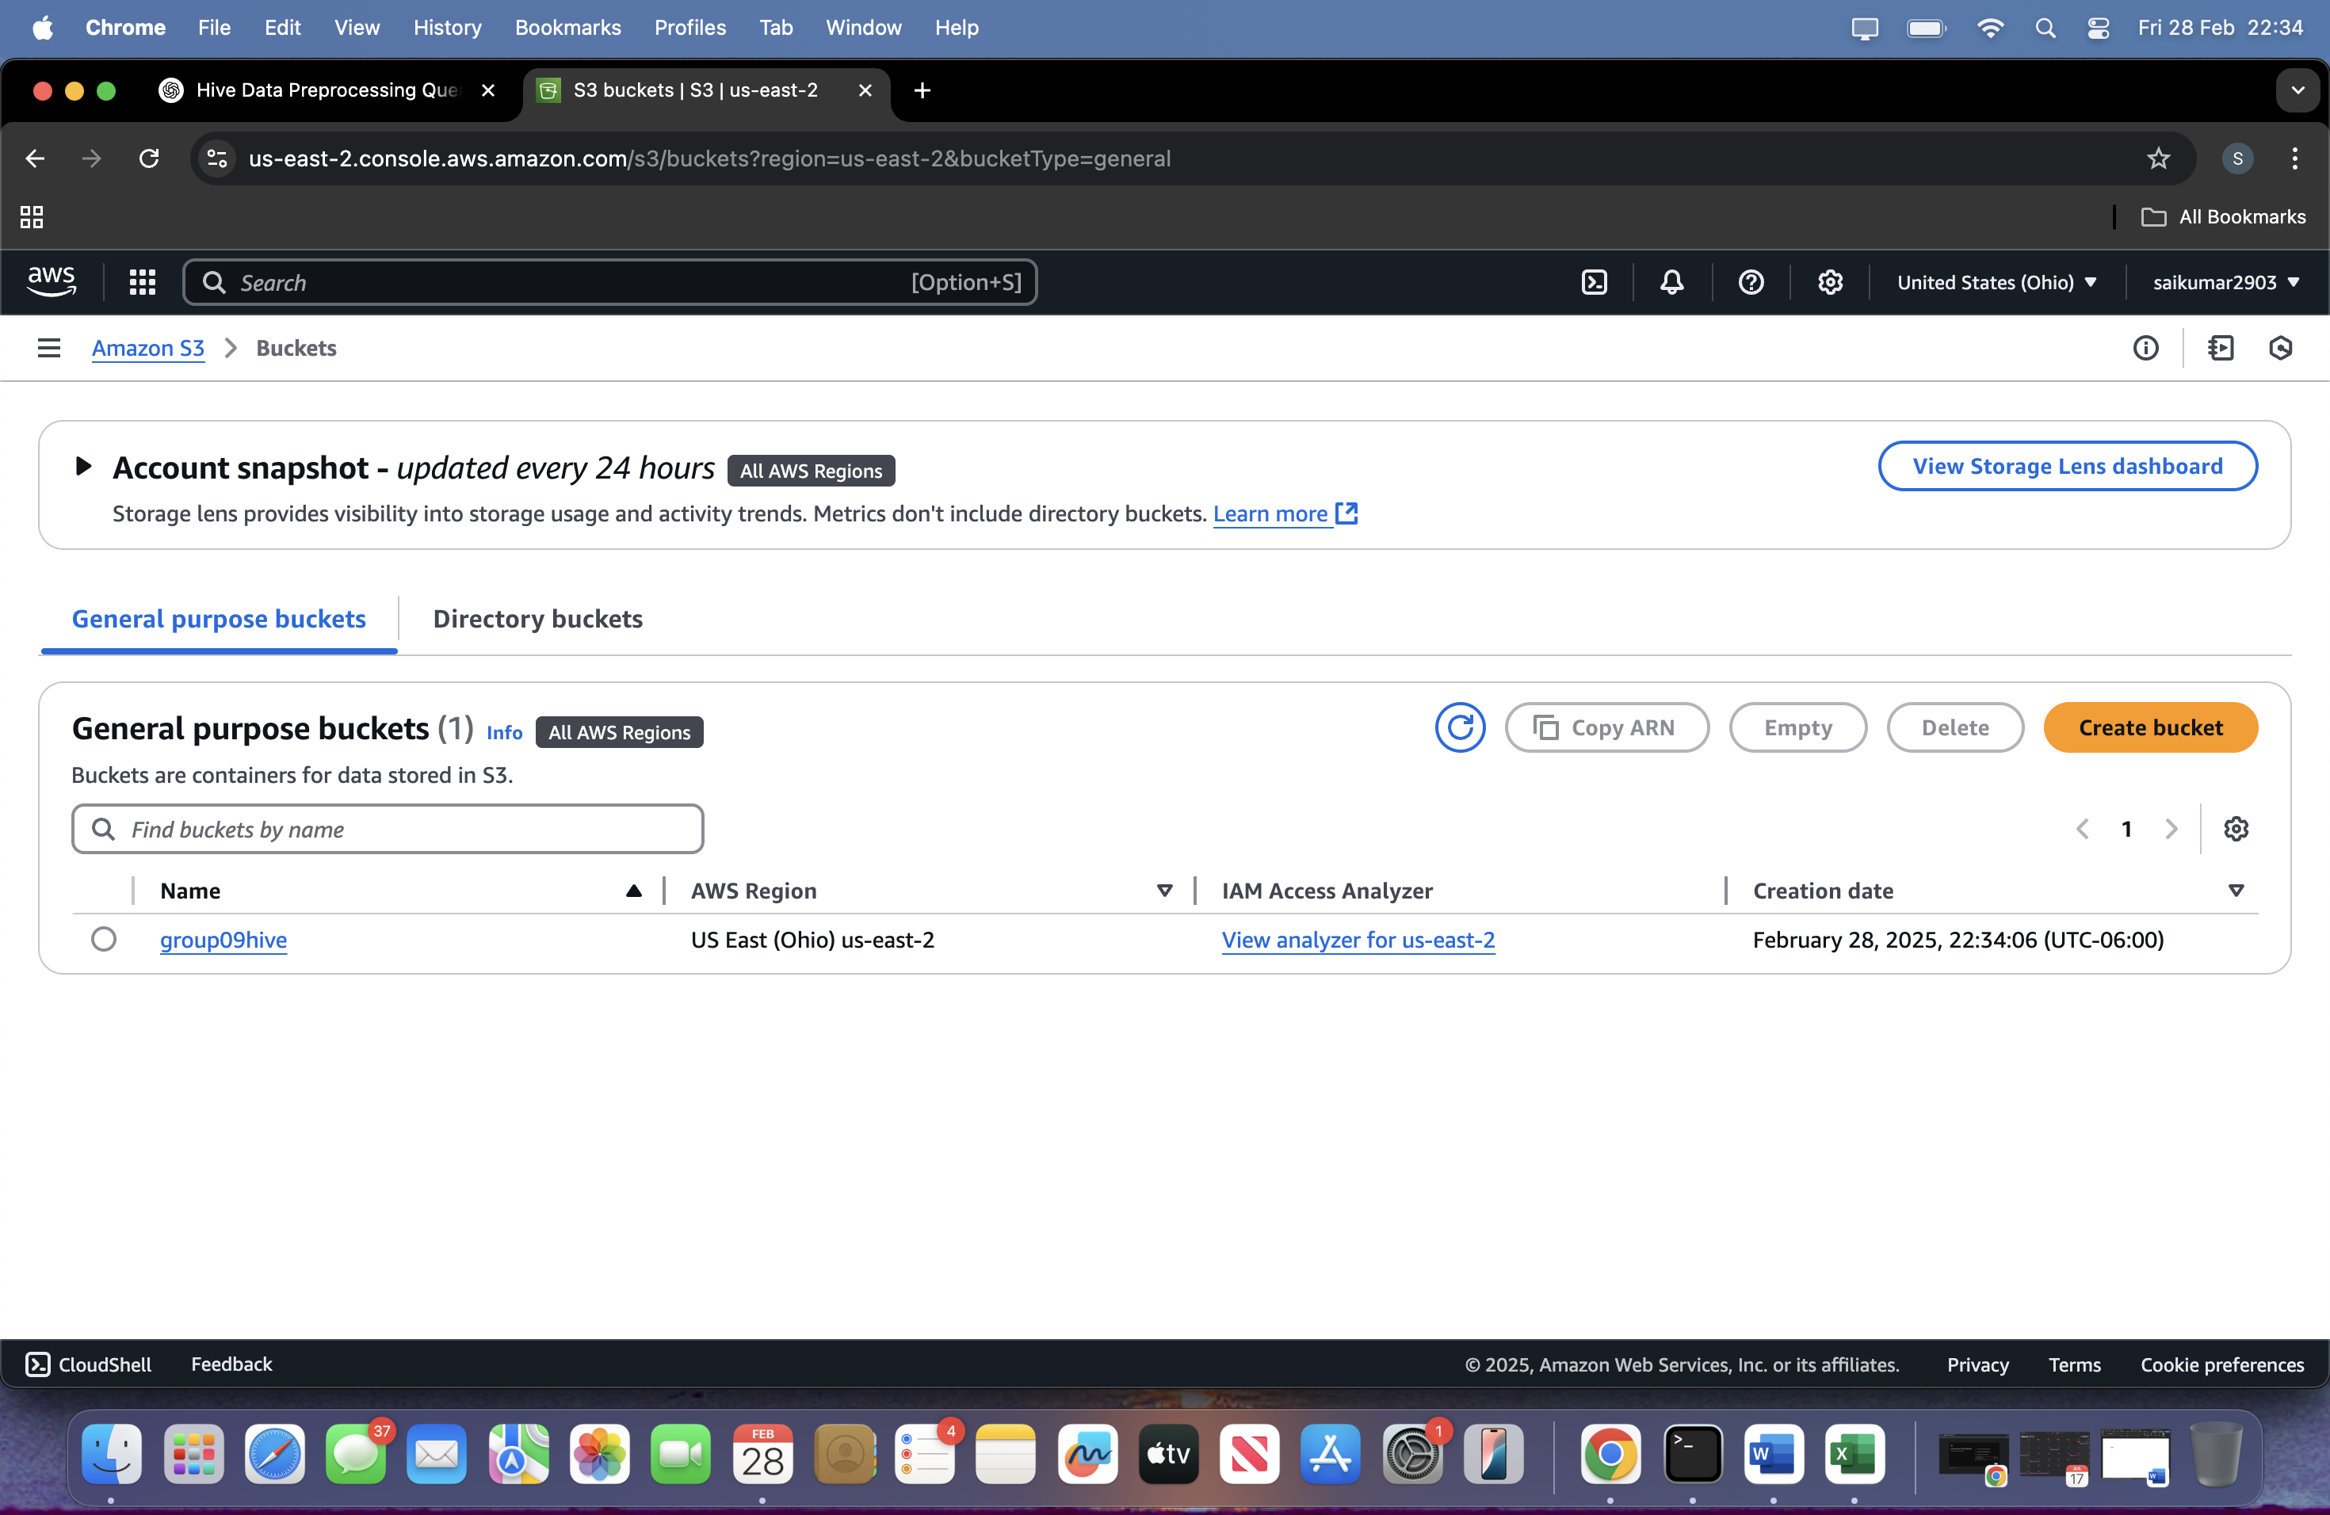  
connecting to the hive:

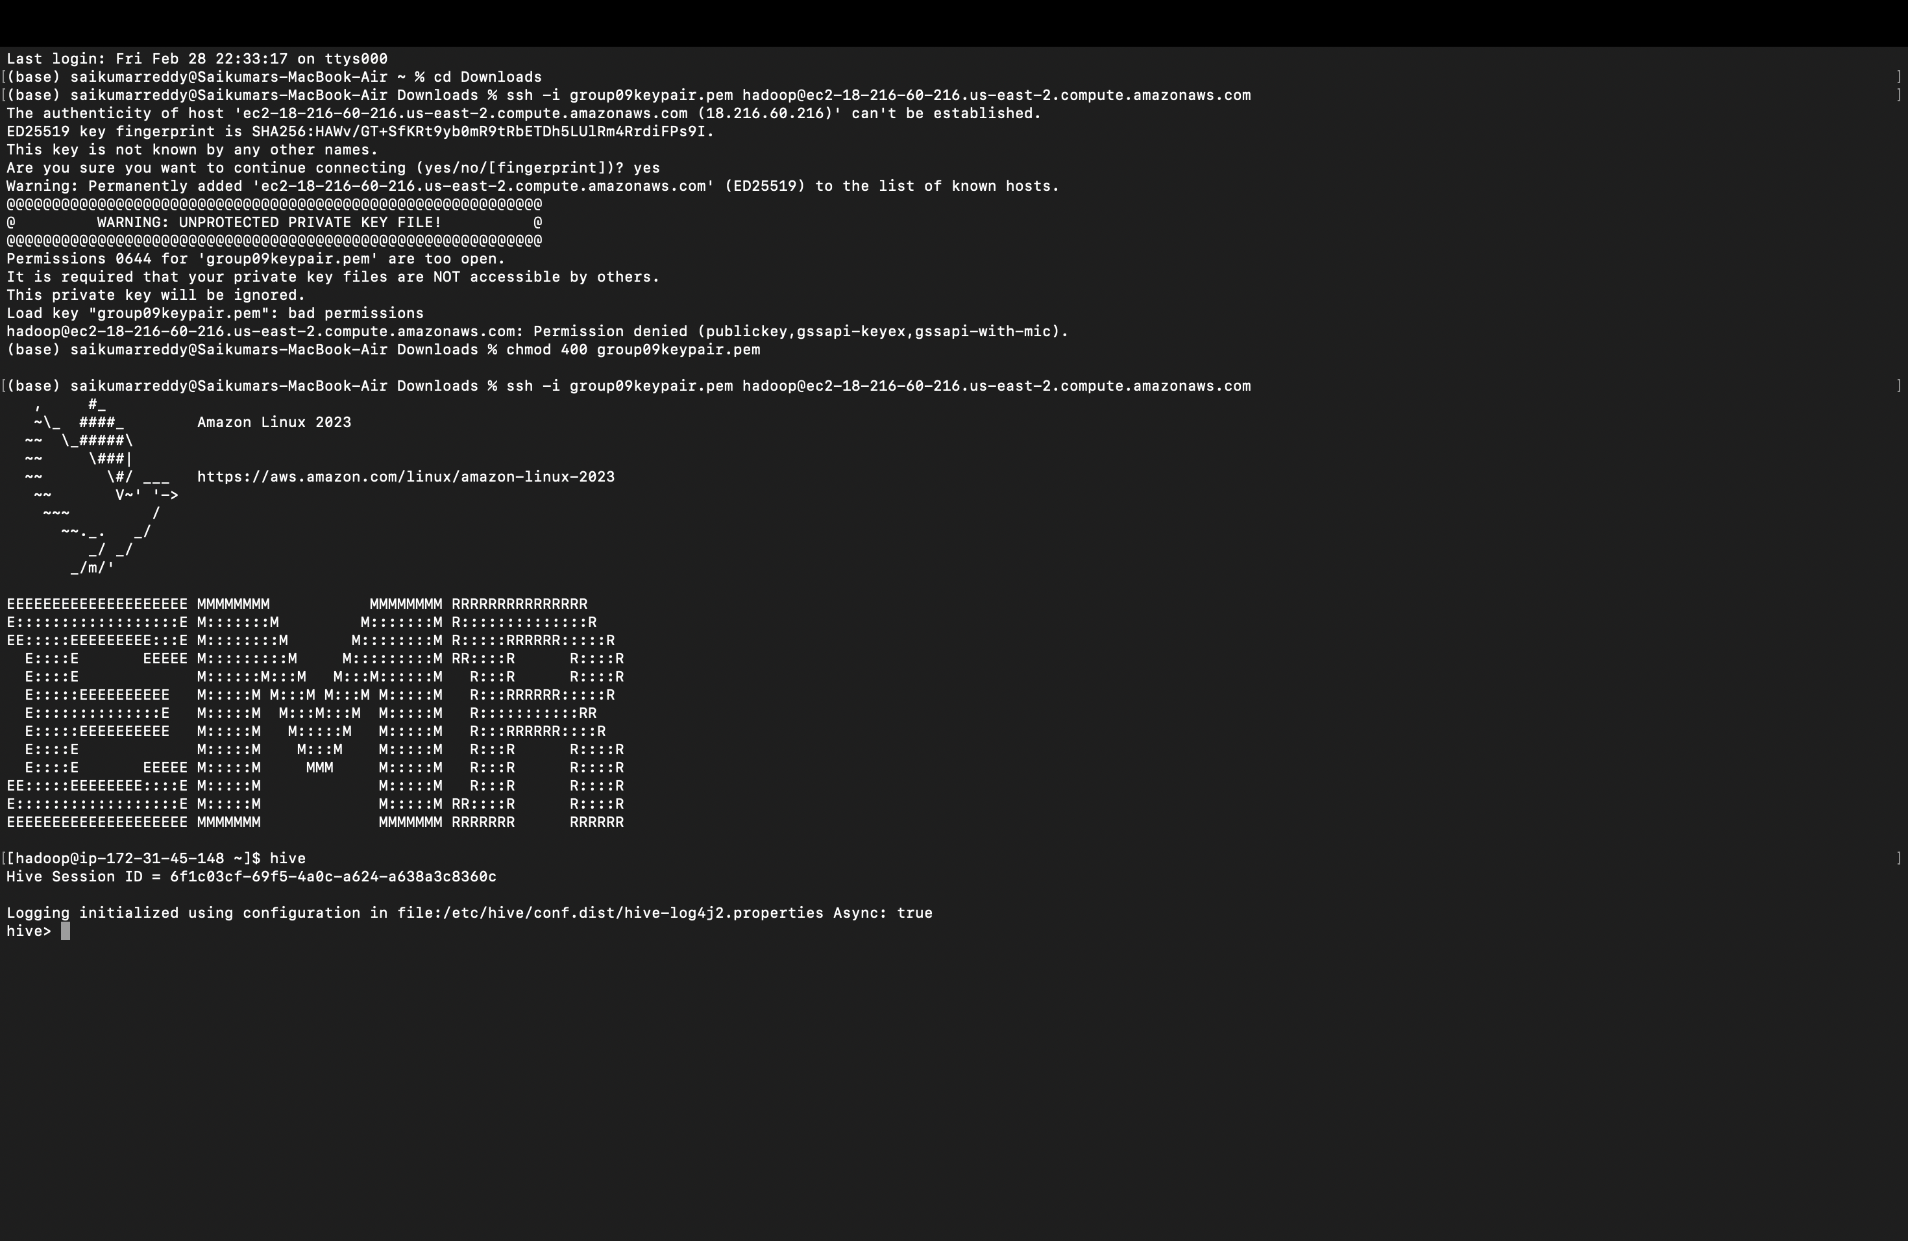  
creating the table:

CREATE TABLE air_quality_raw (

`date` STRING,

`time` STRING,

co_gt FLOAT,

pt08_s1_co FLOAT,

nmhc_gt FLOAT,

c6h6_gt FLOAT,

pt08_s2_nmhc FLOAT,

nox_gt FLOAT,

pt08_s3_nox FLOAT,

no2_gt FLOAT,

pt08_s4_no2 FLOAT,

pt08_s5_o3 FLOAT,

t FLOAT,

rh FLOAT,

ah FLOAT

)

ROW FORMAT SERDE 'org.apache.hadoop.hive.serde2.OpenCSVSerde'

WITH SERDEPROPERTIES (

"separatorChar" = ",",

"skip.header.line.count" = "1"

)

#### **Replace Missing Values (-200) with NULL**

sql

Copy

CREATE TABLE air_quality_cleaned AS

SELECT

`date`,

`time`,

CASE WHEN co_gt = -200 THEN NULL ELSE co_gt END AS co_gt,

CASE WHEN pt08_s1_co = -200 THEN NULL ELSE pt08_s1_co END AS pt08_s1_co,

CASE WHEN nmhc_gt = -200 THEN NULL ELSE nmhc_gt END AS nmhc_gt,

CASE WHEN c6h6_gt = -200 THEN NULL ELSE c6h6_gt END AS c6h6_gt,

CASE WHEN pt08_s2_nmhc = -200 THEN NULL ELSE pt08_s2_nmhc END AS pt08_s2_nmhc,

CASE WHEN nox_gt = -200 THEN NULL ELSE nox_gt END AS nox_gt,

CASE WHEN pt08_s3_nox = -200 THEN NULL ELSE pt08_s3_nox END AS pt08_s3_nox,

CASE WHEN no2_gt = -200 THEN NULL ELSE no2_gt END AS no2_gt,

CASE WHEN pt08_s4_no2 = -200 THEN NULL ELSE pt08_s4_no2 END AS pt08_s4_no2,

CASE WHEN pt08_s5_o3 = -200 THEN NULL ELSE pt08_s5_o3 END AS pt08_s5_o3,

CASE WHEN t = -200 THEN NULL ELSE t END AS t,

CASE WHEN rh = -200 THEN NULL ELSE rh END AS rh,

CASE WHEN ah = -200 THEN NULL ELSE ah END AS ah

FROM air_quality_raw;

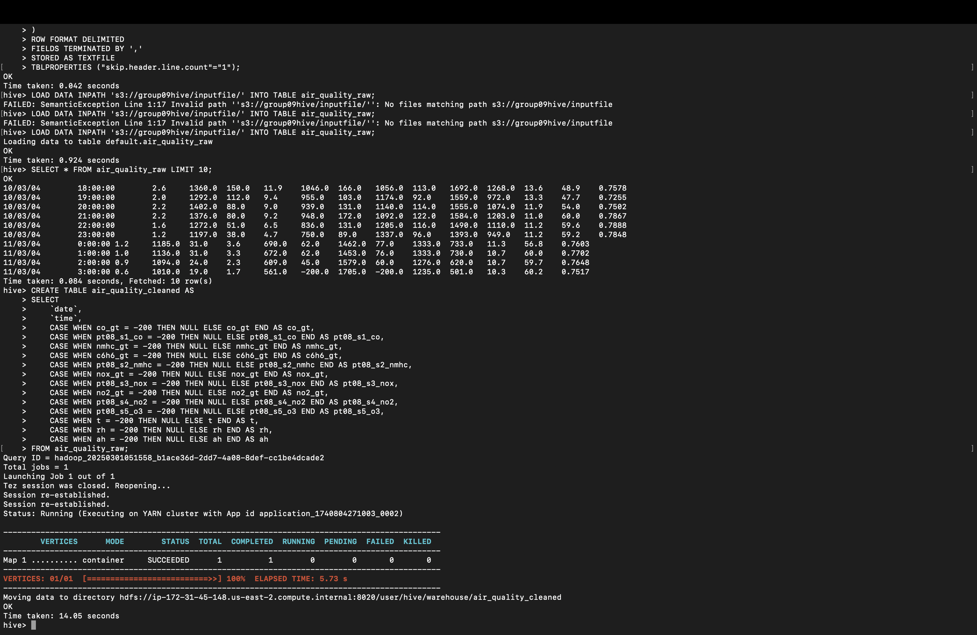  
  
Verify Missing Value Handling

After replacing -200 with NULL in the air_quality_cleaned table, verify the results:

sql

Copy

SELECT * FROM air_quality_cleaned LIMIT 10;

Expected Output:

All -200 values should be replaced with NULL.

Check specific columns like co_gt, nox_gt, etc., to confirm.

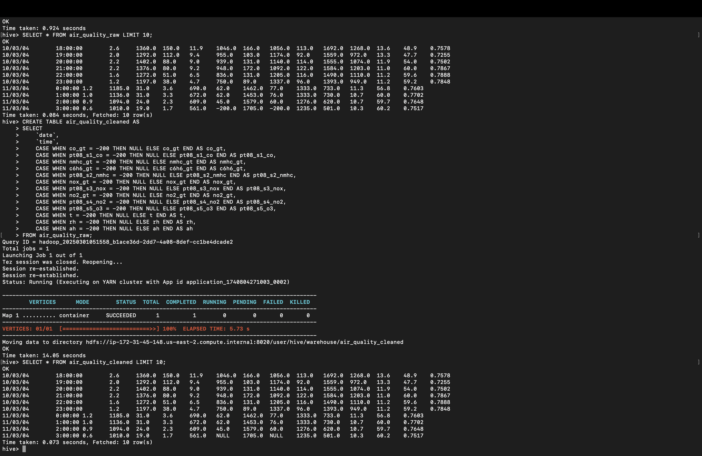

Remove Rows with All NULL Values

sql

Copy

CREATE TABLE air_quality_filtered AS

SELECT *

FROM air_quality_cleaned

WHERE co_gt IS NOT NULL

OR pt08_s1_co IS NOT NULL

OR nmhc_gt IS NOT NULL

OR c6h6_gt IS NOT NULL

OR pt08_s2_nmhc IS NOT NULL

OR nox_gt IS NOT NULL

OR pt08_s3_nox IS NOT NULL

OR no2_gt IS NOT NULL

OR pt08_s4_no2 IS NOT NULL

OR pt08_s5_o3 IS NOT NULL

OR t IS NOT NULL

OR rh IS NOT NULL

OR ah IS NOT NULL;  
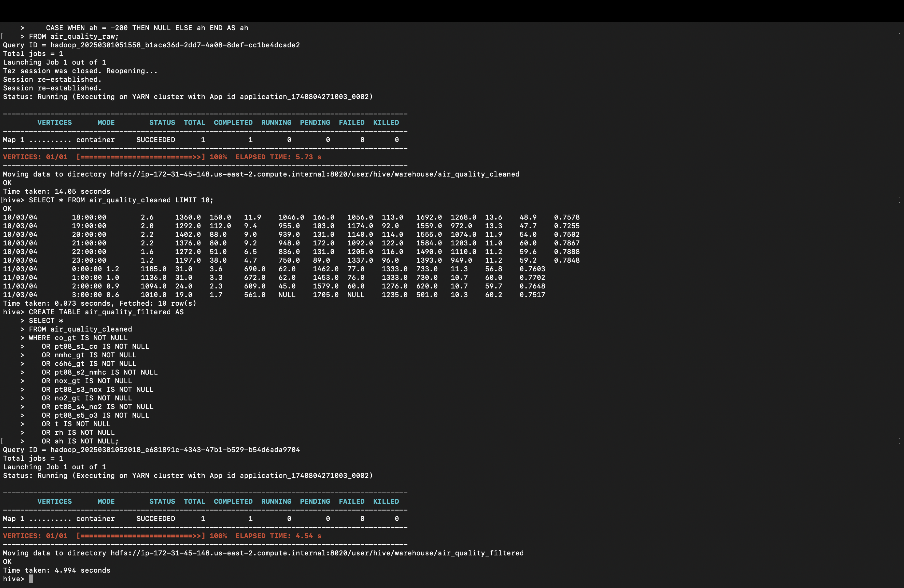  
Step 3:

Verify Filtered Data

After removing rows with all NULL values in the air_quality_filtered table, verify the results:

sql

Copy

SELECT * FROM air_quality_filtered LIMIT 10;

Expected Output:

Rows where all sensor readings are NULL should be removed.

The remaining rows should have at least one non-NULL value.

Step 1: Remove Rows with Any NULL Values

Update the filtering query to remove rows where any column has a NULL value:

sql

Copy

CREATE TABLE air_quality_filtered AS

SELECT *

FROM air_quality_cleaned

WHERE co_gt IS NOT NULL

AND pt08_s1_co IS NOT NULL

AND nmhc_gt IS NOT NULL

AND c6h6_gt IS NOT NULL

AND pt08_s2_nmhc IS NOT NULL

AND nox_gt IS NOT NULL

AND pt08_s3_nox IS NOT NULL

AND no2_gt IS NOT NULL

AND pt08_s4_no2 IS NOT NULL

AND pt08_s5_o3 IS NOT NULL

AND t IS NOT NULL

AND rh IS NOT NULL

AND ah IS NOT NULL;

Explanation:

This query ensures that all columns must have non-NULL values for a row to be included in the air_quality_filtered table.

Step 2: Verify Filtered Data

After running the updated query, verify the results:

sql

Copy

SELECT * FROM air_quality_filtered LIMIT 10;

Expected Output:

No NULL values should be present in any column.

Rows with NULL values in any column should be removed.

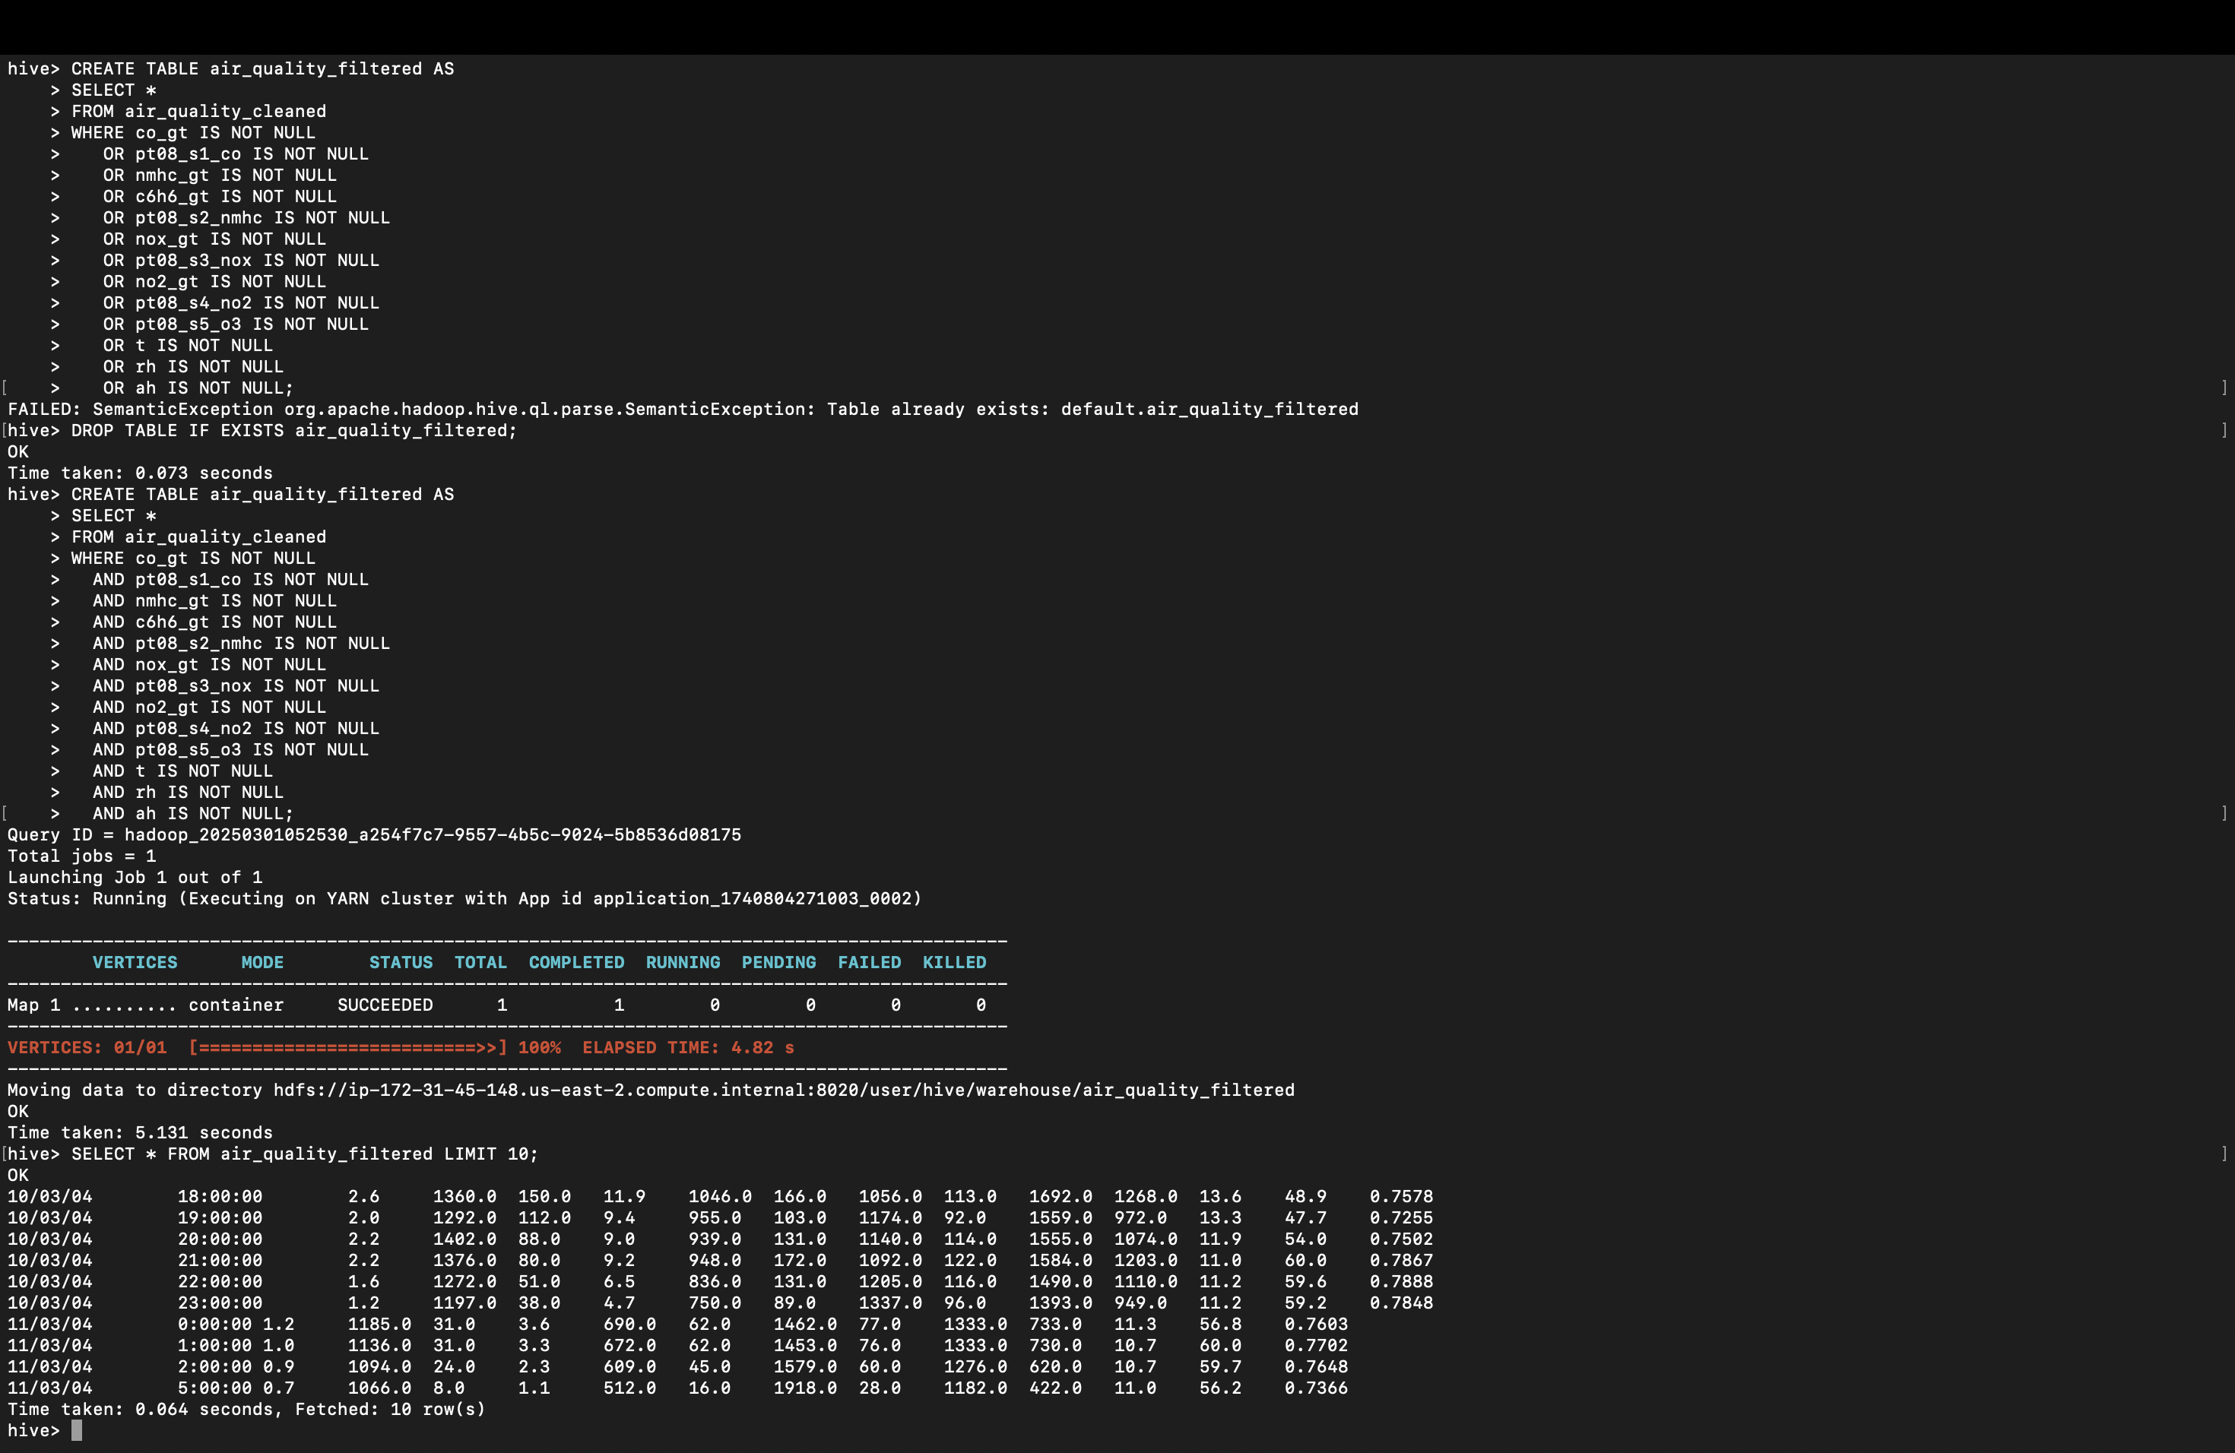  
Normalize the Data

Now, normalize the data in the air_quality_filtered table. Since all NULL values have been removed, the normalization will work correctly.

Query for Normalization:

sql

Copy

CREATE TABLE air_quality_normalized AS

SELECT

`date`,

`time`,

(co_gt - MIN(co_gt) OVER ()) / (MAX(co_gt) OVER () - MIN(co_gt) OVER ()) AS co_gt_norm,

(pt08_s1_co - MIN(pt08_s1_co) OVER ()) / (MAX(pt08_s1_co) OVER () - MIN(pt08_s1_co) OVER ()) AS pt08_s1_co_norm,

(nmhc_gt - MIN(nmhc_gt) OVER ()) / (MAX(nmhc_gt) OVER () - MIN(nmhc_gt) OVER ()) AS nmhc_gt_norm,

(c6h6_gt - MIN(c6h6_gt) OVER ()) / (MAX(c6h6_gt) OVER () - MIN(c6h6_gt) OVER ()) AS c6h6_gt_norm,

(pt08_s2_nmhc - MIN(pt08_s2_nmhc) OVER ()) / (MAX(pt08_s2_nmhc) OVER () - MIN(pt08_s2_nmhc) OVER ()) AS pt08_s2_nmhc_norm,

(nox_gt - MIN(nox_gt) OVER ()) / (MAX(nox_gt) OVER () - MIN(nox_gt) OVER ()) AS nox_gt_norm,

(pt08_s3_nox - MIN(pt08_s3_nox) OVER ()) / (MAX(pt08_s3_nox) OVER () - MIN(pt08_s3_nox) OVER ()) AS pt08_s3_nox_norm,

(no2_gt - MIN(no2_gt) OVER ()) / (MAX(no2_gt) OVER () - MIN(no2_gt) OVER ()) AS no2_gt_norm,

(pt08_s4_no2 - MIN(pt08_s4_no2) OVER ()) / (MAX(pt08_s4_no2) OVER () - MIN(pt08_s4_no2) OVER ()) AS pt08_s4_no2_norm,

(pt08_s5_o3 - MIN(pt08_s5_o3) OVER ()) / (MAX(pt08_s5_o3) OVER () - MIN(pt08_s5_o3) OVER ()) AS pt08_s5_o3_norm,

(t - MIN(t) OVER ()) / (MAX(t) OVER () - MIN(t) OVER ()) AS t_norm,

(rh - MIN(rh) OVER ()) / (MAX(rh) OVER () - MIN(rh) OVER ()) AS rh_norm,

(ah - MIN(ah) OVER ()) / (MAX(ah) OVER () - MIN(ah) OVER ()) AS ah_norm

FROM air_quality_filtered;

Verify Normalized Data:

sql

Copy

SELECT * FROM air_quality_normalized LIMIT 10;

Expected Output:

All normalized columns (e.g., co_gt_norm, pt08_s1_co_norm) should have values between 0 and 1.

No NULL values should be present.

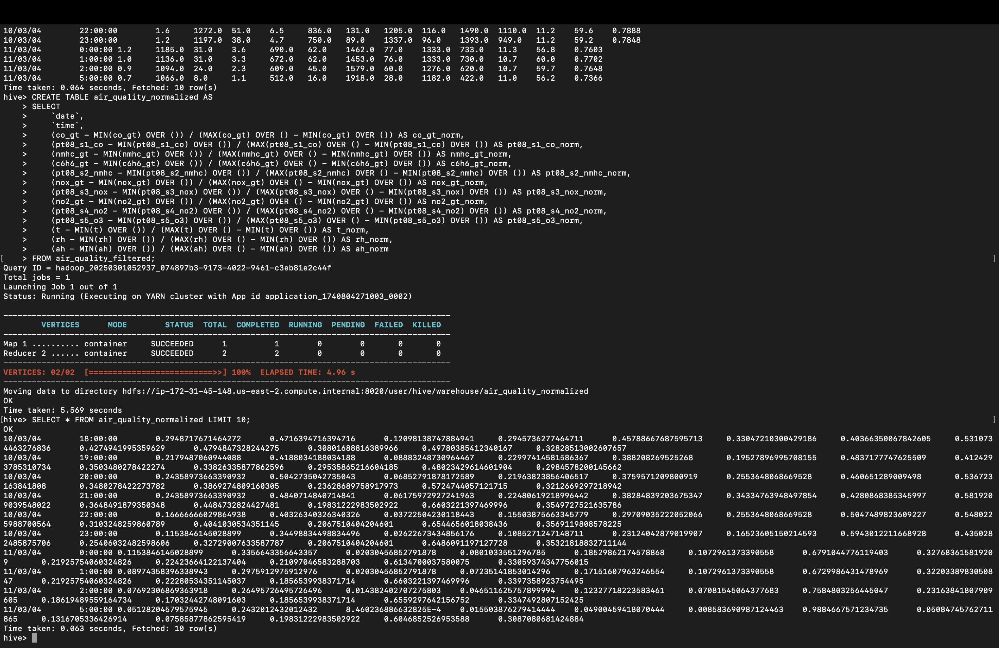  
  
Aggregate Data by Date

sql

Copy

CREATE TABLE air_quality_daily AS

SELECT

`date`,

AVG(co_gt) AS avg_co_gt,

AVG(pt08_s1_co) AS avg_pt08_s1_co,

AVG(nmhc_gt) AS avg_nmhc_gt,

AVG(c6h6_gt) AS avg_c6h6_gt,

AVG(pt08_s2_nmhc) AS avg_pt08_s2_nmhc,

AVG(nox_gt) AS avg_nox_gt,

AVG(pt08_s3_nox) AS avg_pt08_s3_nox,

AVG(no2_gt) AS avg_no2_gt,

AVG(pt08_s4_no2) AS avg_pt08_s4_no2,

AVG(pt08_s5_o3) AS avg_pt08_s5_o3,

AVG(t) AS avg_t,

AVG(rh) AS avg_rh,

AVG(ah) AS avg_ah

FROM air_quality_filtered

GROUP BY `date`;  
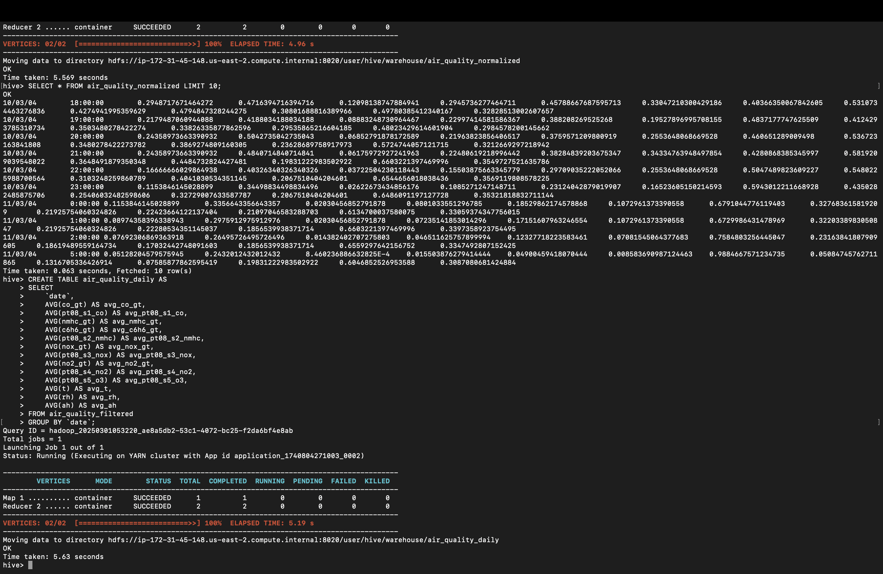  
Verify Aggregated Data

After aggregating the data by date in the air_quality_daily table, verify the results:

sql

Copy

SELECT * FROM air_quality_daily LIMIT 10;  
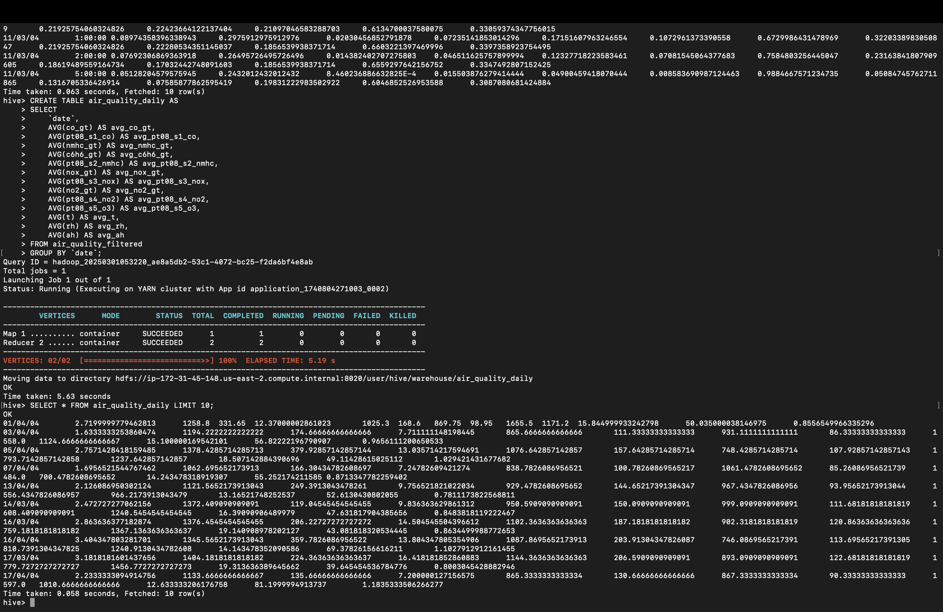

Find Days with High CO Levels

sql

Copy

SELECT `date`, AVG(co_gt) AS avg_co_gt

FROM air_quality_filtered

GROUP BY `date`

HAVING AVG(co_gt) > 2.0;

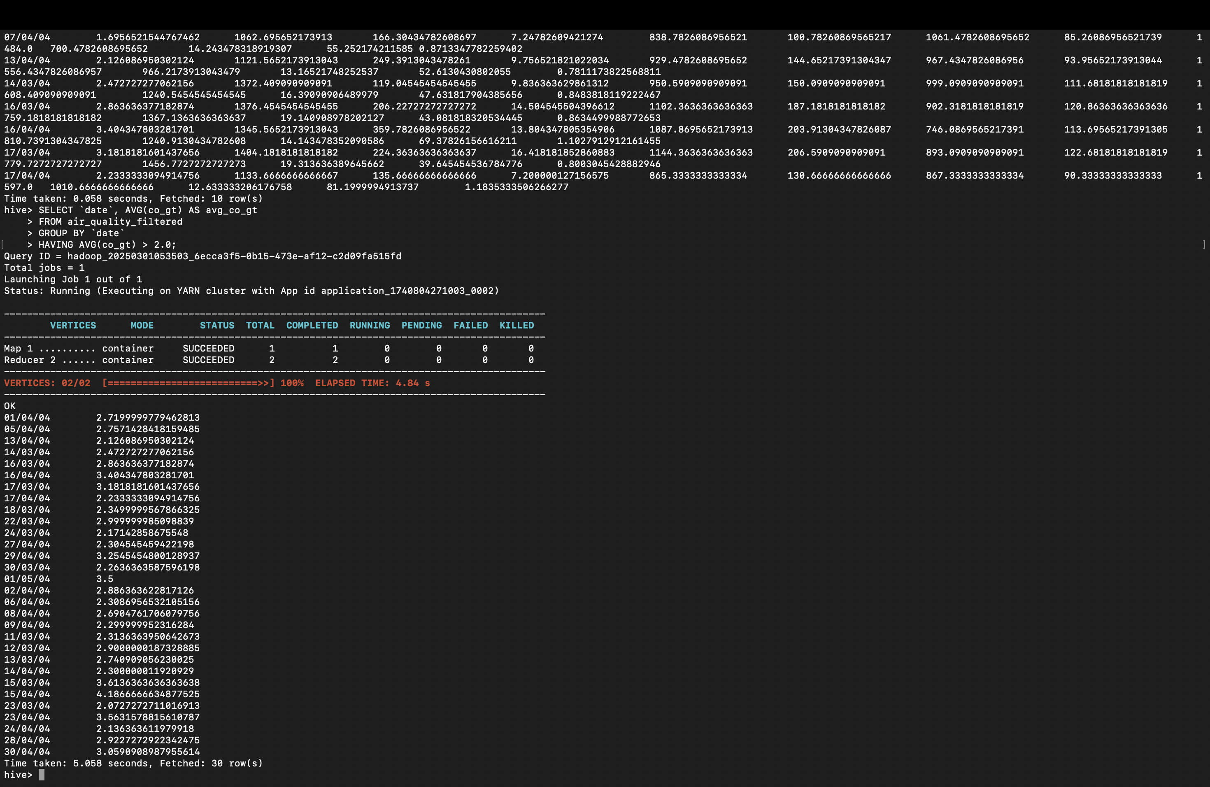

Verify High Ozone Levels

After finding days with high ozone levels, verify the results:

sql

Copy

SELECT `date`, AVG(pt08_s5_o3) AS avg_pt08_s5_o3

FROM air_quality_filtered

GROUP BY `date`

HAVING AVG(pt08_s5_o3) > 1000;

Expected Output:

Only dates where the average pt08_s5_o3 is greater than 1000 should be returned.  
  
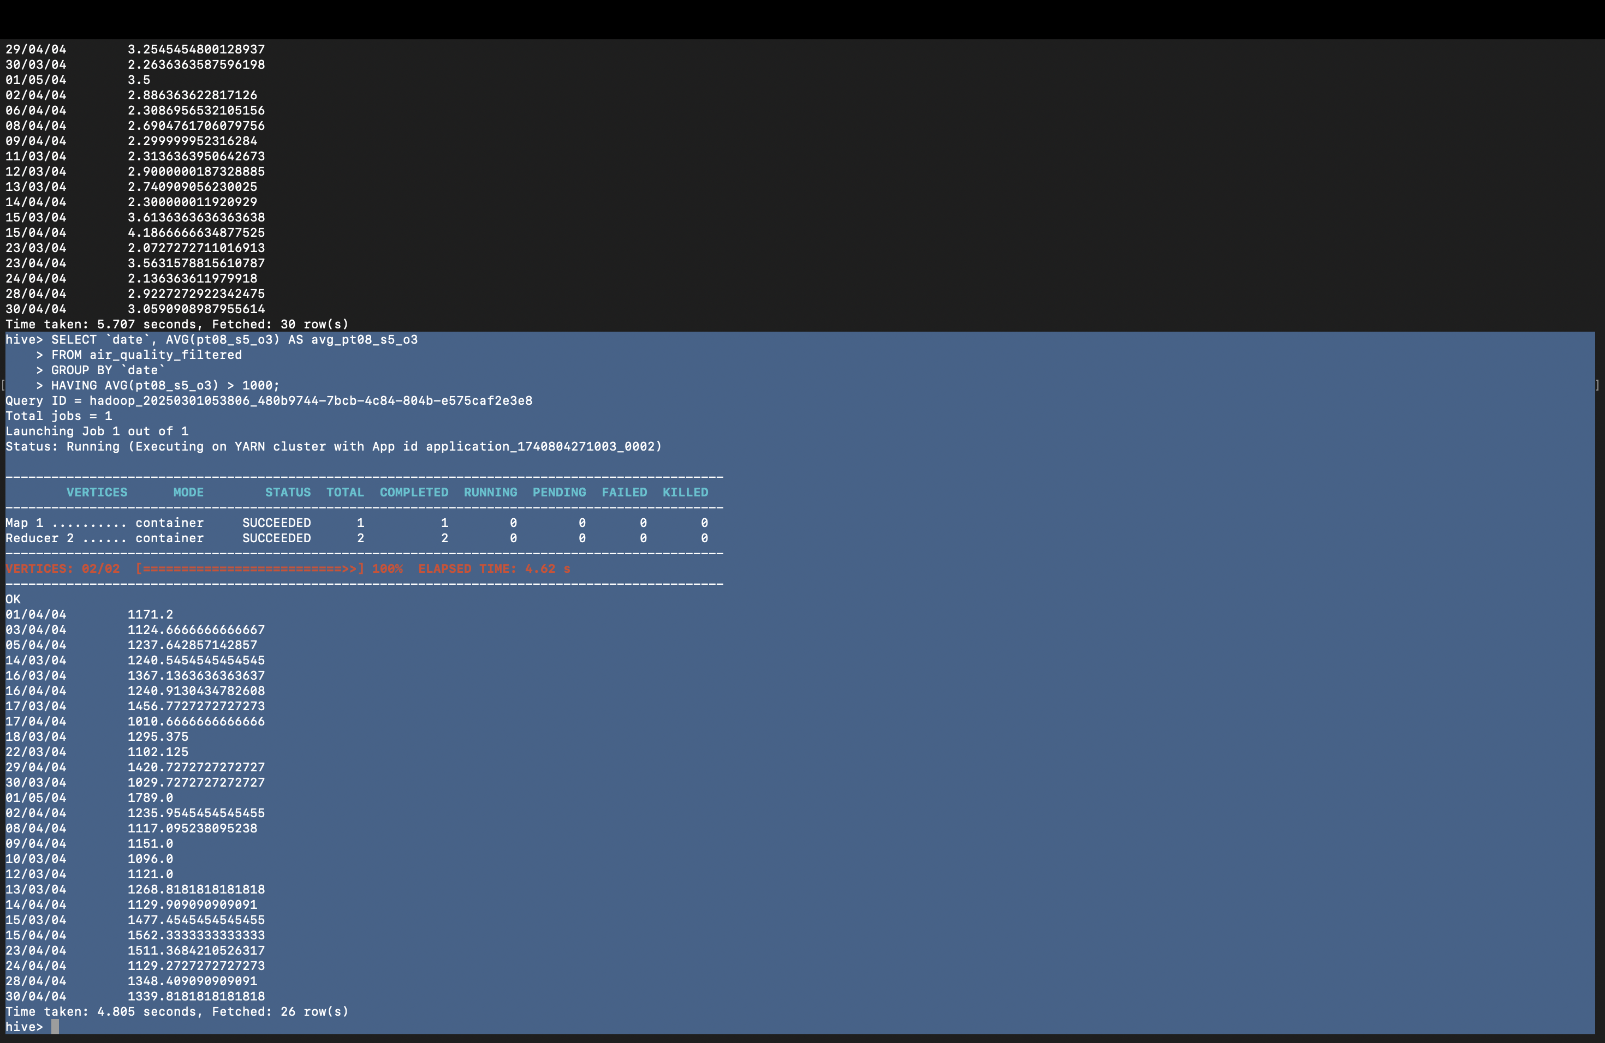

Verify High Pollution Days

After finding days with high pollution levels, verify the results:

sql

Copy

SELECT `date`, AVG(co_gt) AS avg_co_gt, AVG(nox_gt) AS avg_nox_gt, AVG(no2_gt) AS avg_no2_gt

FROM air_quality_filtered

GROUP BY `date`

HAVING AVG(co_gt) > 2.0 AND AVG(nox_gt) > 150 AND AVG(no2_gt) > 100;

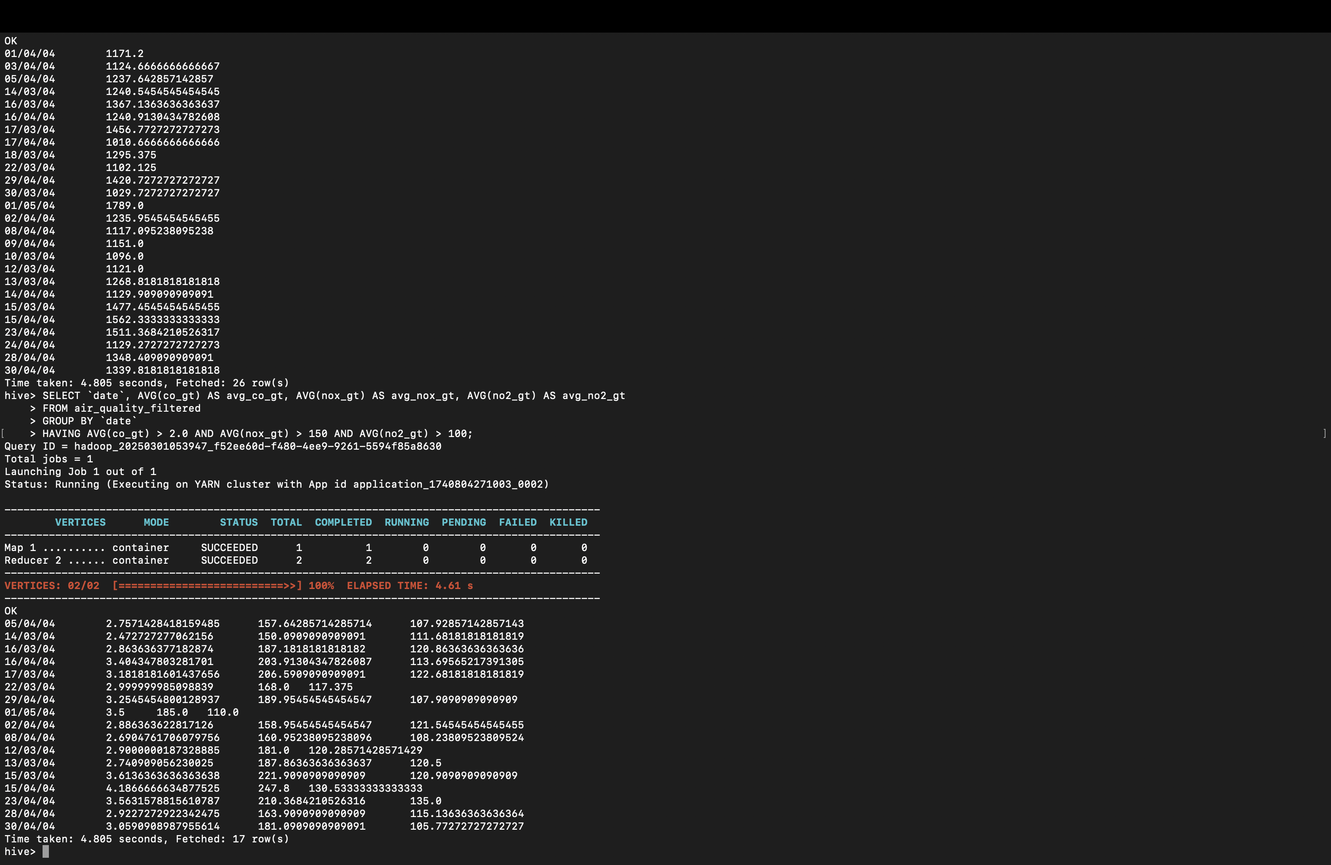

Verify Temperature Values

Check the range of temperature values in your dataset:

sql

Copy

SELECT MIN(t) AS min_t, MAX(t) AS max_t, AVG(t) AS avg_t

FROM air_quality_filtered;

Expected Output:

min_t: Minimum temperature in the dataset.

max_t: Maximum temperature in the dataset.

avg_t: Average temperature across the dataset.

If max_t is less than or equal to 25.0, it confirms that no days have an average temperature greater than 25.0.

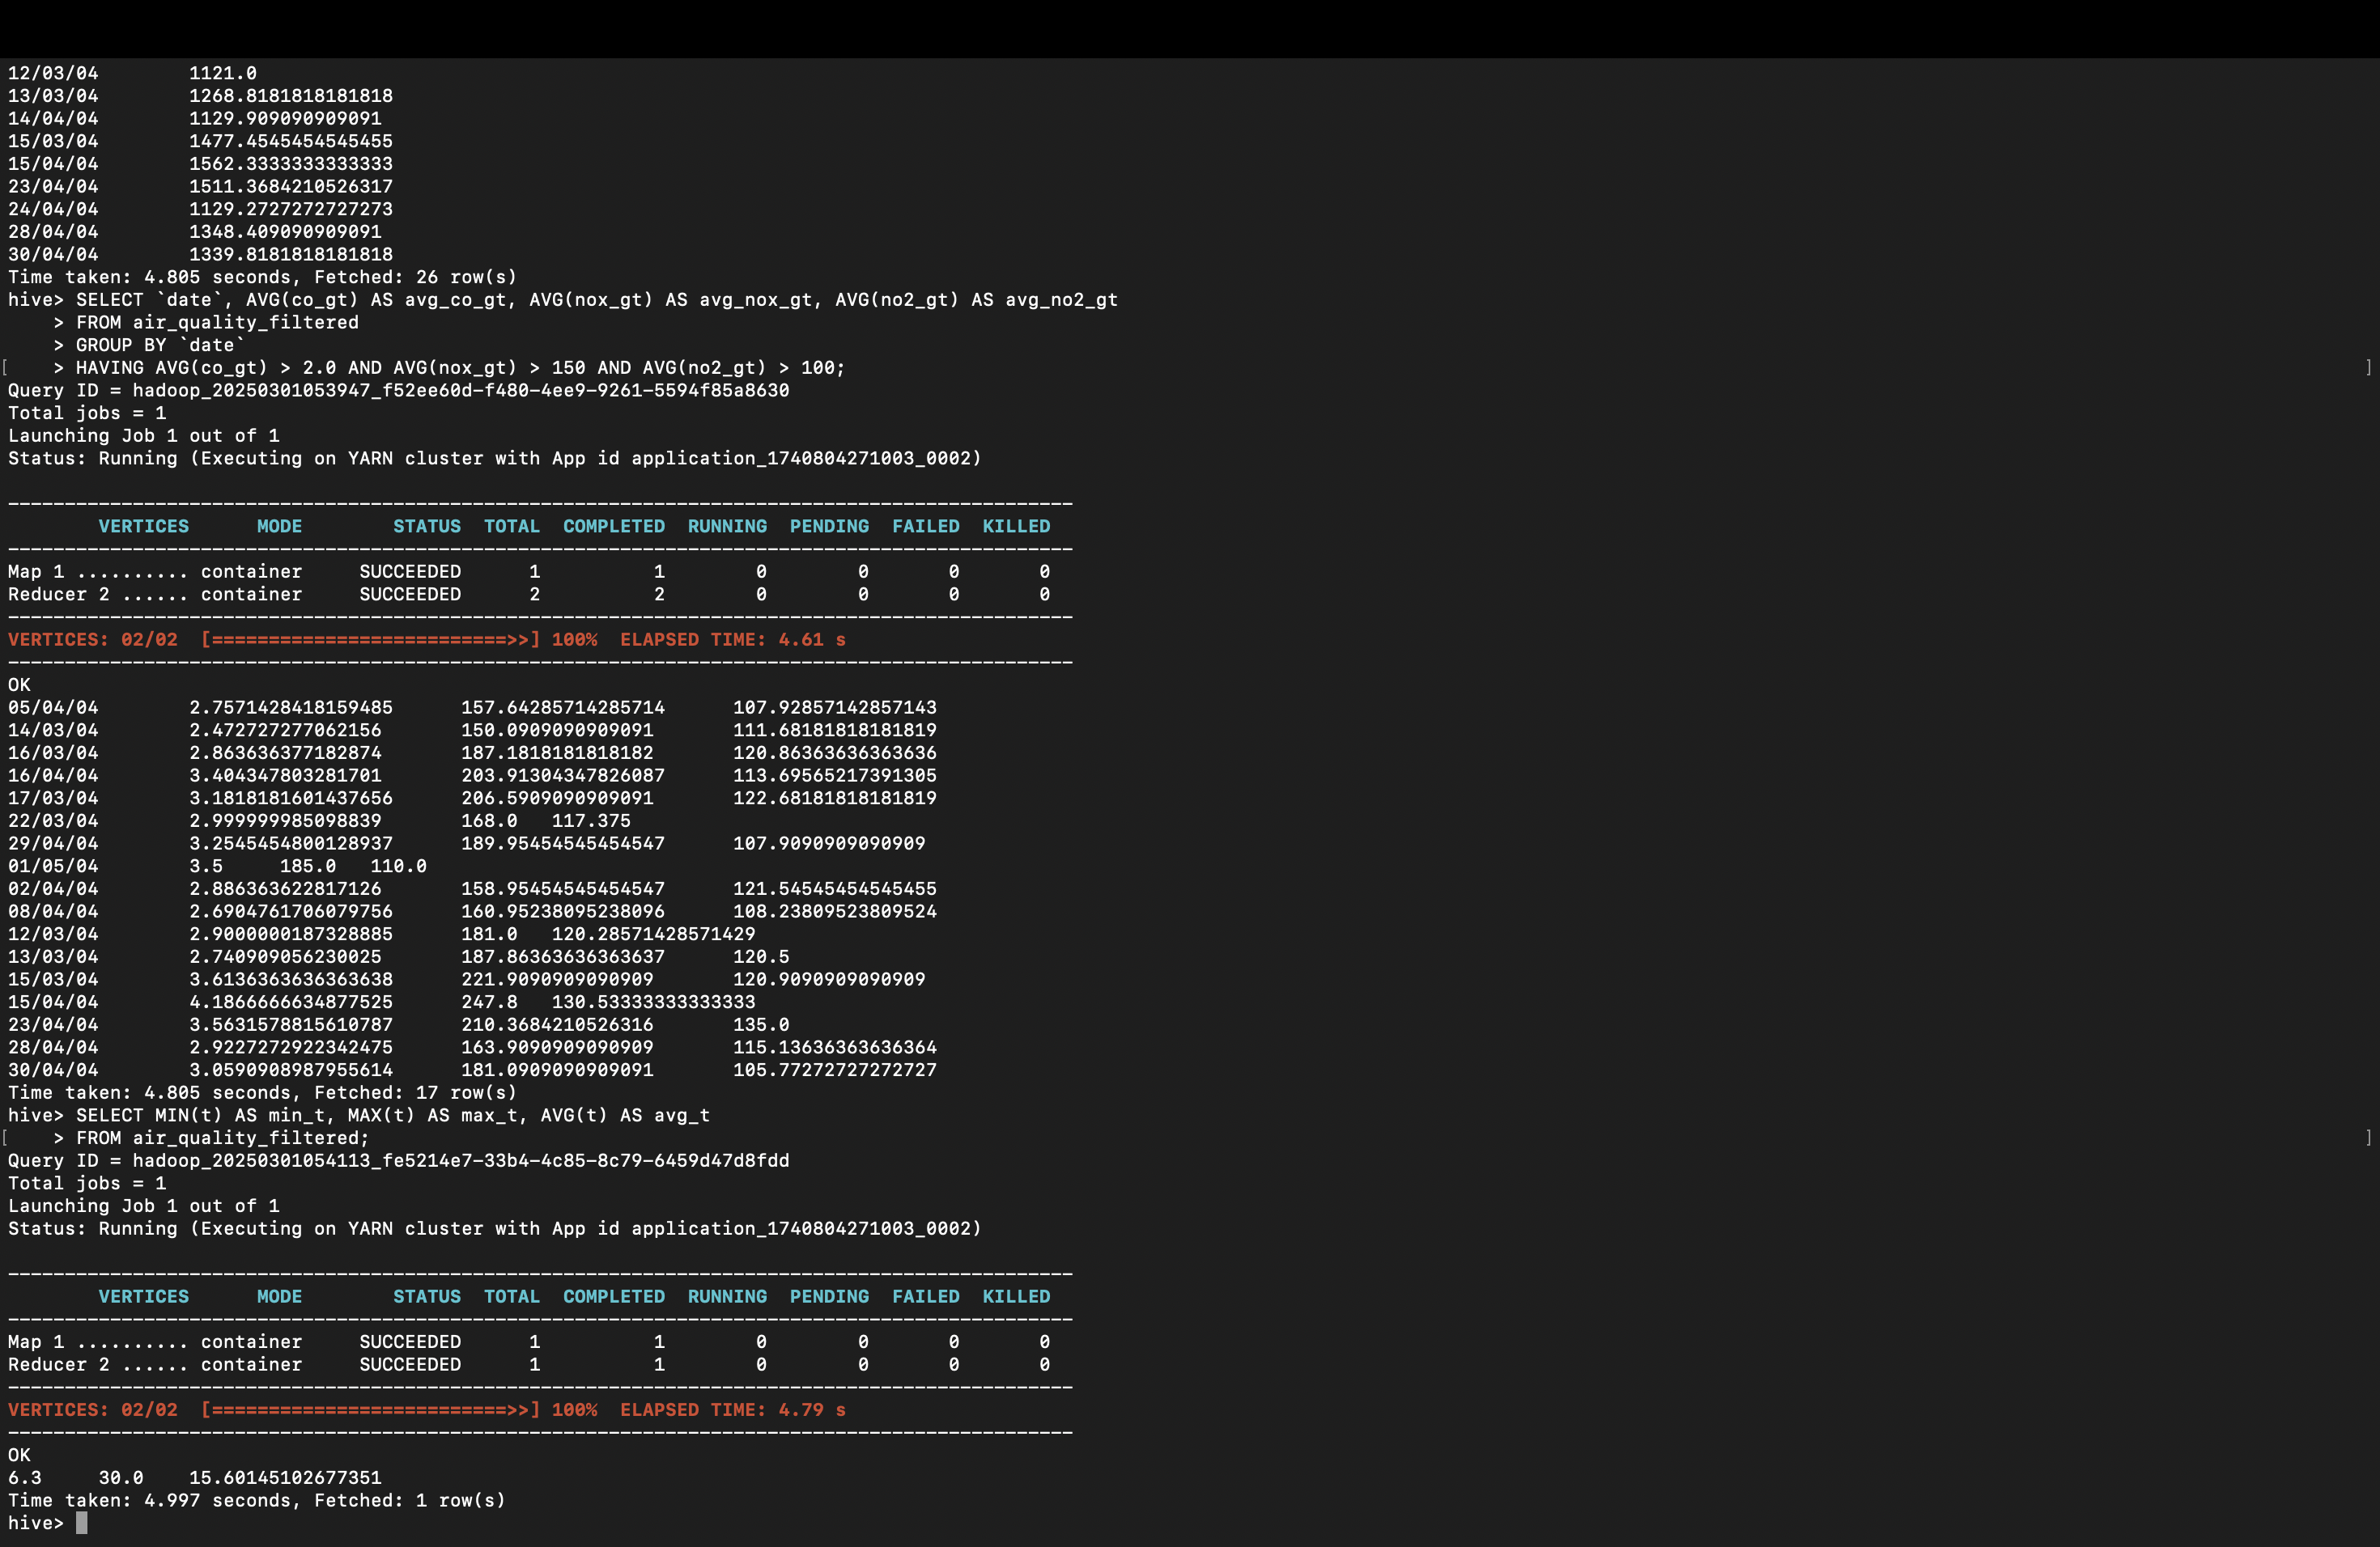  
  
Save Processed Data to S3

To save the processed data (e.g., air_quality_filtered or air_quality_daily) to S3, use the INSERT OVERWRITE DIRECTORY command in Hive.

Example: Save air_quality_filtered to S3

sql

Copy

INSERT OVERWRITE DIRECTORY 's3://group09hive/output/air_quality_filtered/'

ROW FORMAT DELIMITED

FIELDS TERMINATED BY ','

STORED AS TEXTFILE

SELECT * FROM air_quality_filtered;  
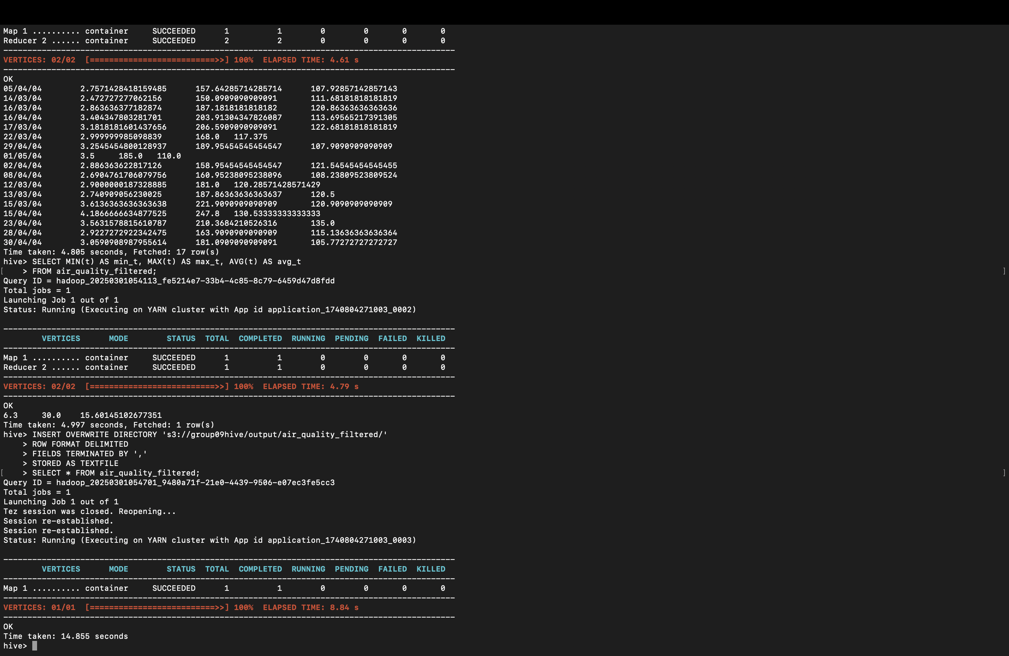

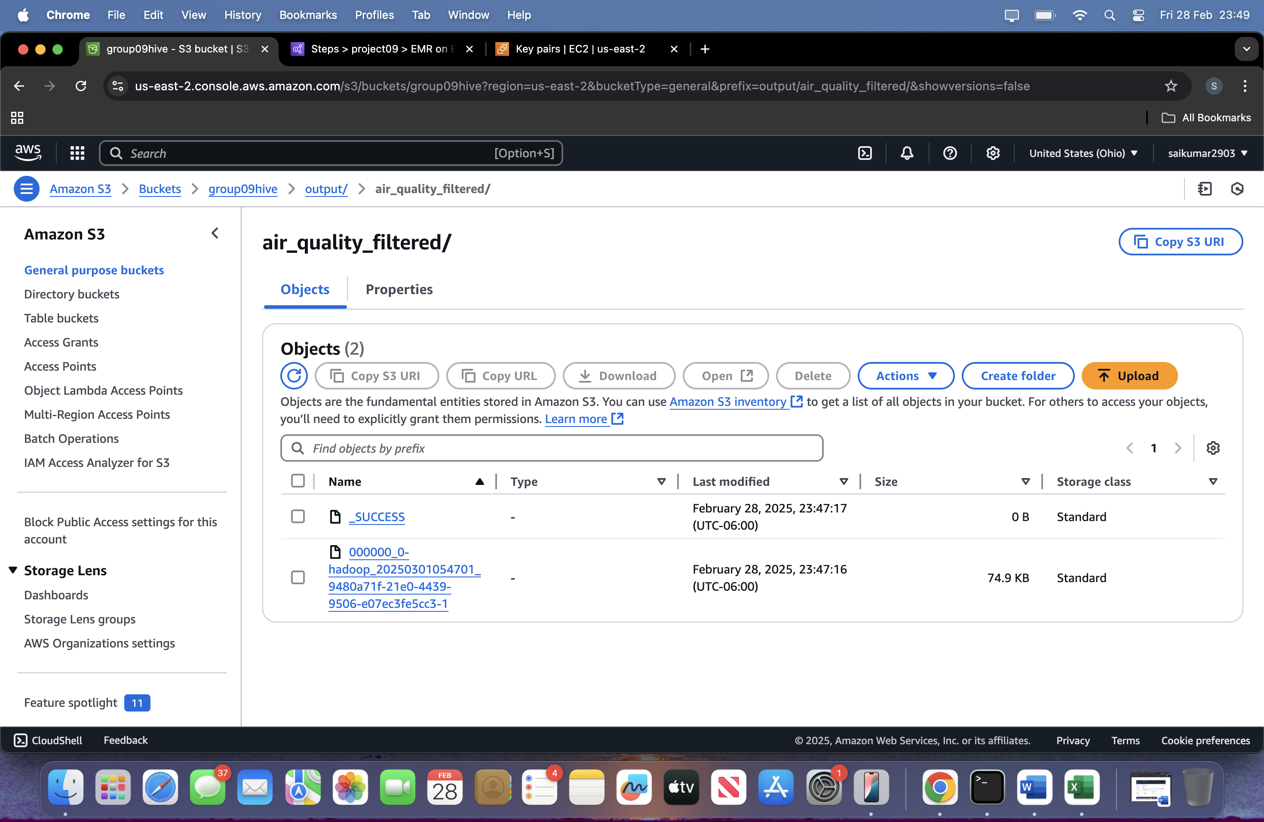  
  
CREATE TABLE air_quality.daily_metrics (

date TEXT PRIMARY KEY,

avg_co_gt FLOAT,

avg_pt08_s1_co FLOAT,

avg_nmhc_gt FLOAT,

avg_c6h6_gt FLOAT,

avg_pt08_s2_nmhc FLOAT,

avg_nox_gt FLOAT,

avg_pt08_s3_nox FLOAT,

avg_no2_gt FLOAT,

avg_pt08_s4_no2 FLOAT,

avg_pt08_s5_o3 FLOAT,

avg_t FLOAT,

avg_rh FLOAT,

avg_ah FLOAT

);

DYANAMO DB

import boto3

import csv

from decimal import Decimal # Import Decimal for numeric values

# Initialize DynamoDB client

dynamodb = boto3.resource('dynamodb', region_name='us-east-1') # Replace with your region

table = dynamodb.Table('air_quality_metrics')

# Read data from S3

s3 = boto3.client('s3')

bucket_name = 'group09hive'

key = 'output/air_quality_filtered/000000_0-hadoop_20250301054701_9480a71f-21e0-4439-9506-e07ec3fe5cc3-1'

response = s3.get_object(Bucket=bucket_name, Key=key)

lines = response['Body'].read().decode('utf-8').splitlines()

# Insert data into DynamoDB

for row in csv.reader(lines):

table.put_item(

Item={

'date': row[0], # Partition key

'time': row[1], # Sort key

'avg_co_gt': Decimal(str(row[2])), # Convert to Decimal

'avg_pt08_s1_co': Decimal(str(row[3])), # Convert to Decimal

'avg_nmhc_gt': Decimal(str(row[4])), # Convert to Decimal

'avg_c6h6_gt': Decimal(str(row[5])), # Convert to Decimal

'avg_pt08_s2_nmhc': Decimal(str(row[6])), # Convert to Decimal

'avg_nox_gt': Decimal(str(row[7])), # Convert to Decimal

'avg_pt08_s3_nox': Decimal(str(row[8])), # Convert to Decimal

'avg_no2_gt': Decimal(str(row[9])), # Convert to Decimal

'avg_pt08_s4_no2': Decimal(str(row[10])), # Convert to Decimal

'avg_pt08_s5_o3': Decimal(str(row[11])), # Convert to Decimal

'avg_t': Decimal(str(row[12])), # Convert to Decimal

'avg_rh': Decimal(str(row[13])), # Convert to Decimal

'avg_ah': Decimal(str(row[14])) # Convert to Decimal

}

)

print("Data loaded into DynamoDB successfully!")